**EXPERIMENT - 4**

**Configure RIP routing Protocol in Routers**

**Sanjana Niranjan -1BM22CS418**

**Topology:**

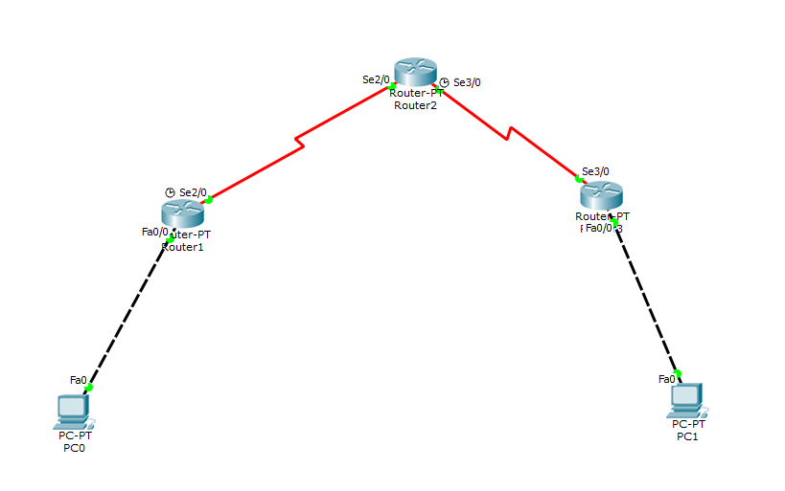

**Configuring IP address for all interfaces:**

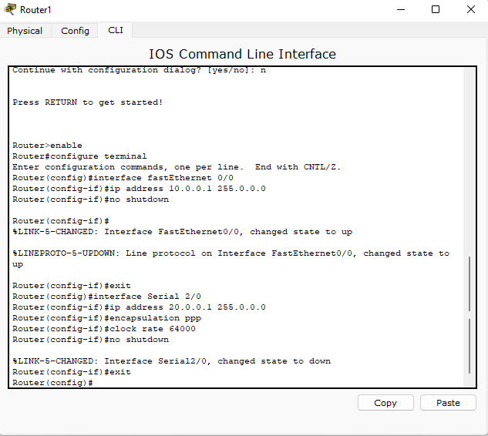

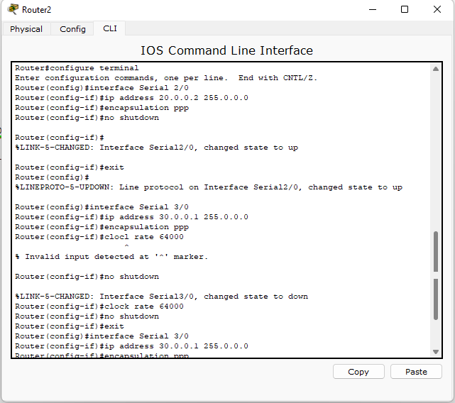

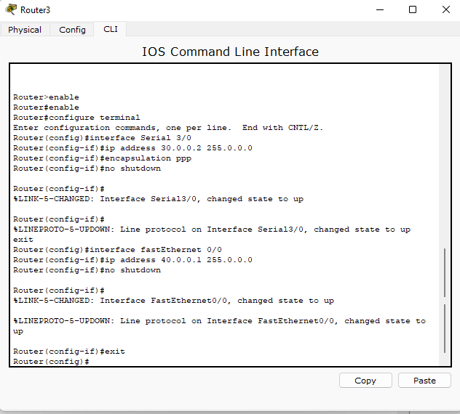

**Configure RIP to all routers**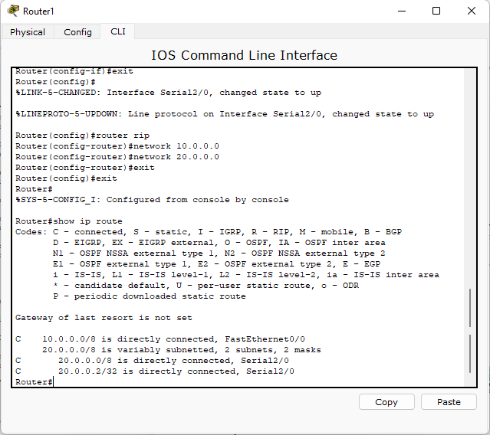

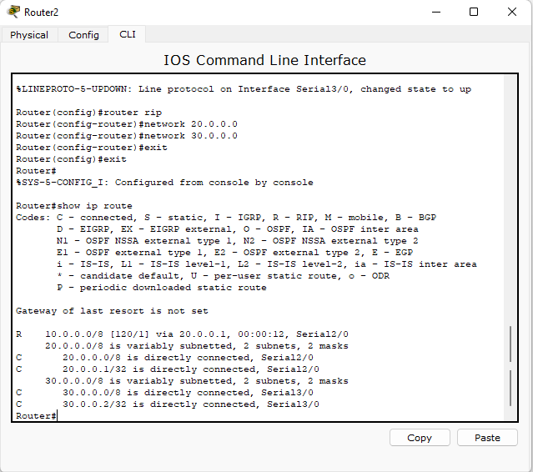

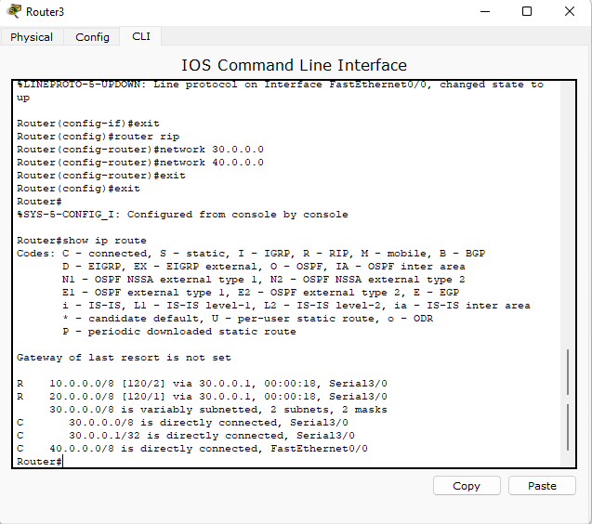

**Ping from 10.0.0.10 to 40.0.0.10**

